Bid Evaluation Report

Procurement of School Furniture

**Bid Evaluation Report**

**&**

**Recommendation for Award of Contract**

**Procurement of School Furniture for Primary, Middle & High Schools**

|  |  |
| --- | --- |
| **Country:** | Pakistan |
| **Project Name:** | Global Partnership for Education – Balochistan Education Project (GPE-BEP), Secondary Education Department, Government of Balochistan. |

**IBRD Loan or IDA Credit No.:** TF019124

**Identification Number:** P144454

**Procurement Plan Ref: Activity No: 15**

**Contract Name:** Procurement of School Furniture

**Date of Submission: 27th February, 2017**

**Table of Contents**

Section I 3

Bid Evaluation Standard Forms 3

Table 1. Identification 5

Table 2. Bidding Process 6

Table 3. Bid Submission and Opening 7

Table 4. Bid Prices (as Read Out) 8

Table 5. Preliminary Examination 9

Table 6. Qualification Requirements and Additional Criteria Requirements 11

Table 7 (a): Five Comparable Scale Projects 13

Table 7 (b): Five Comparable Scale Projects 13

Table 8. Corrections and Unconditional Discounts 14

Section II 15

Evaluation Process Findings and Recommendations 15

Table 8 (a). Proposed Contract Award 17

Table 8 (a). Proposed Contract Award 19

Annex A 21

Annex B 23

Annex C 25

Annex D 26

Annex E 27

Annex F 28

## 

# Section I

# Bid Evaluation Standard Forms

The Government of Balochistan, Secondary Education Department is implementing a Project Global Partnership for Education-Balochistan Education Project (GPE-BEP). The objective of project is to increase school enrollment and retention in project supported schools, with a special focus on girls’ participation, and to develop mechanisms to improve quality of school management through 725 primary schools establishment, up-gradation of 95 schools from primary to middle and up-gradation of 25 schools from middle to high (secondary) level schools.

The Project Management Unit (PMU), Global Partnership for Education – Balochistan Education Project (GPE-BEP) has published Invitation for Bid (IFBs) on 2nd October, 2016, in the National Newspaper Daily Jang and Dawn (English) and also uploaded on UNDP website for procurement of School Furniture, consisting of five lots, Lot-1 for Middle and High School Furniture, Lot-2 Primary School Furniture, Lot-3 Tables and Chairs for ECE Classes, Lot-4 Resource Center Furniture for High School and Lot-5 Furniture for Principal’s Office, under Guidelines: Procurement of Goods, Works and Non-Consulting Service under IBRD Loans and IDA Credits & Grants by World Bank borrowers, January 2011 (revised July 2014) **Section II International Competitive Bidding (ICB**) Method of Procurement.

PMU intended to apply part of the funds to cover eligible payments under the Project Agreement and invited sealed bids on items rates for five (5) lots from eligible bidders for the following goods:

|  |  |  |  |
| --- | --- | --- | --- |
| **Lot 1 – Middle and High School Furniture** | | | |
| **S.No** | **Item Name** | **Quantity** | **Unit** |
| 1 | One Arm Tablet chair | 1844 | No |
| 2 | Duel Desk with Bench | 3720 | No |
|  |  |  |  |
| **Lot- 2 Primary School Furniture** | | | |
| 1 | One Arm Tablet chair | 600 | No |
| 2 | Multiple Purpose Table | 12000 | No |
|  |  |  |  |
| **Lot-3 Tables and Chairs for ECE Classes** | | | |
| 1 | Table and chairs for ECE class | 62 | No |
| 2 | Round table | 62 | No |
| 3 | Rectangle Table | 248 | No |
|  |  |  |  |
| **Lot-4 Resource Center Furniture for High School** | | | |
| 1 | Computer Chair | 360 | No |
| 2 | Computer Table | 360 | No |
| 3 | Conference Table | 36 | No |
| 4 | Chair For Resource Center | 240 | No |
| 5 | Stool For Science Lab | 240 | No |
|  |  |  |  |
| **Lot-5 Furniture for Principal’s Office** | | | |
| 1 | Visitors Chair | 72 |  |
| 2 | Office table with Mobile drawer | 12 |  |
| 3 | Revolving Chair | 12 |  |
| 4 | Book Shelves | 36 |  |

The evaluation of the following bids and contract award was done lot wise. Against the above 5 lots thirty (30) firms/bidders issued the bid document while Seven (7) firms submitted their bid documents within the due date and time i.e. 14th November, 2016, 11:00 AM.

Subsequently, the Bids were opened under in camera session and in the presence of Bidder’s and Procurement Evaluation Committee.

The Tender Evaluation Committee members attended the bid opening were.

|  |  |
| --- | --- |
| 1) Mr. Aziz A. Jamali Additional Secretary Education | Member |
| 2) Mr. Asfand Yar Khan PD, GPE-BEP | Chairman |
| 3) Mr. Haroon, Manager Education, GPE-BEP | Member |
| 4) Mr. Naseeb Ullah, Manager M&E, GPE-BEP | Member |
| 5) Muhammad Usman, Rep: Finance Dept., GOB | Member |
| 6) Mr. Irfan Ahmed, Procurement Specialist, GPE-BEP | Member |

## Table 1. Identification

|  |  |
| --- | --- |
| **1.1 Name of Borrower** | Islamic Republic of Pakistan  Secondary Education Department, PMU  Government of Balochistan, Pakistan. |
| **1.2 Loan/Credit Number** | TF019124 |
| **1.3 Closing date**  (a) Original  (b) Revised | 14th November, 2016  N/A |
| **1.4 Name of Project** | Global Partnership for Education - Balochistan Education Project (GPE-BEP) |
| **1.5 Purchaser (or Employer)**  (a) Name  (b) Address | Project Director, Global Partnership for Education – Balochistan Education Project (GPE- BEP)  H. No. A-2, Chaman Housing Scheme, Airport Road Quetta. |
| **1.6 Contract Number (identification)** | GPE-BEP/ICB/Goods/2016/02  PP/Goods-Activity-15 |
| **1.7 Contract Description** | Procurement of School Furniture |
| **1.8 Cost Estimate** | **$ 858,490** |
| **1.9 Method of Procurement** | ICB |
| **1.10 Prior Review Required** | Yes |
| **1.11 Domestic Preference Allowed** | Yes |
| **1.12 Fixed Price Contract** | Yes |
| **1.13 Co-financing, if any:**  (a) Agency Name  (b) Percent Financed by Agency | Not Applicable |

## Table 2. Bidding Process

|  |  |
| --- | --- |
| **2.1 General Procurement Notice**  (a) First Issue Date  (b) Latest Update | 2nd October, 2016  N/A |
| **2.2 Prequalification, if required**  (a) Number of Firms Prequalified  (b) Date of Bank’s no-objection | Not Applicable |
| **2.3 Specific Procurement Notice**  (a) Name of National Newspaper  (b) Issue Date  (c) Name of International Publication  (d) Issue date  (e) Number of Firms Notified | Daily Jung Newspaper, Dawn Newspaper  2nd October, 2011  Web upload on UNDP website  30th September, 2016  N/A |
| **2.4 Standard Bidding Document**  (a) Title, Publication Date  (b) Bate of Bank’s no-objection  (c) Date of Issue to Bidders | Procurement of School Furniture  2nd October, 2016  19th September, 2016  2nd October, 2016 |
| **2.5 Number of Firms Issued Documents** | Thirty (30) |
| **2.6 Amendments to Documents, if any**  (a) list all issue dates  (b) date(s) of Bank’s no-objection | Not Applicable |
| **2.7 Date of Pre-bid Conference, if any** | 24th October, 2016 |
| **2.8 Date Minutes of Conference sent to Bidders and Bank** | 4th November, 2016 |

## Table 3. Bid Submission and Opening

|  |  |
| --- | --- |
| **3.1** **Bid submission deadline**  (a) Original Date, Time  (b) Extensions, if any | 14th November 2016, 11:00 Am  No |
| **3.2 Bid Opening Date, Time** | 14th November 2016, 11:00 Am |
| **3.3 Record of bid Opening, Data sent to Bank** | Yes |
| **3.4 Number of bids submitted** | Seven (07) |
| **3.5 Bid validity period (days or weeks)**  (a) Originally Specified  (b) Extensions, if any  (c) Date of Bank’s no-objection, if required | 90 Days  Yes, Another 40 Days  5th February, 2017 |
| It is also pertinent to mention here that the initial bid validity period was 90 days which was further extended for another 40 days due to expiry of initial bid validity period.  A request for extension of Bids Validity Period, was send via e-mail on 07th February 2017 for another 40 days to all bidders/firms participated in the bid. | |

## Table 4. Bid Prices (as Read Out)

|  |  |  |  |  |  |  |  |  |  |  |
| --- | --- | --- | --- | --- | --- | --- | --- | --- | --- | --- |
| **Option 1 Rosewood (Sheeshum)** | | | | | | | | | | |
|  | **Bidder Identification** | | | **Read Out Lot Prices** | | | | | **Total in PKR (e)** | **Modifications (f)** |
| **S. No** | **Firm Name (a)** | **City (b)** | **Country (c)** | **Lot 1 (Middle & High School Furn)** | **Lot 2 (Primary School Furn)** | **Lot 3 (Tables & Chairs for ECE )** | **Lot 4 (Resource Center Furn)** | **Lot 5 (Furniture for Principal)** |
| 1 | Haji Dawood & Co | Quetta | Pakistan | 22,176,096 | 28,025,340 | 3,434,924 | 3,817,080 | 1,360,536 | 58,813,976 |  |
| 2 | Mukhtar Safe & Co | Quetta | Pakistan | 25,745,140 | 22,761,000 | 4,191,200 | 4,615,500 | 778,140 | 58,090,980 |  |
| 3 | A&A Brothers | Quetta | Pakistan | 46,234,144 | 46,275,600 | 7,395,484 | 9,319,944 | 1,233,504 | 110,458,676 |  |
| 4 | Mehran Enterprises Karachi | Karachi | Pakistan | 44,565,116 | 23,495,400 | 6,460,400 | 5,184,000 | 1,390,800 | 81,095,716 |  |
| 5 | Euro Gulf International | Quetta | Pakistan | - | - | 4,060,380 | 3,509,352 | 886,925 | 8,456,657 |  |
| 6 | Haleemi Traders | Quetta | Pakistan | **-** | **-** | 3,986,600 | 4,470,000 | 739,680 | 9,196,280 |  |
| 7 | Comforta Furniture | Islamabad | Pakistan | 25,907,200 | 84,930,000 | 10,582,000 | 9,806,000 | 1,414,400 | 132,639,600 |  |

|  |  |  |  |  |  |  |  |  |  |  |
| --- | --- | --- | --- | --- | --- | --- | --- | --- | --- | --- |
| **Option 2 Acacia (Keeker)** | | | | | | | | | | |
|  | **Bidder Identification** | | | **Read Out Lot Prices** | | | | | **Total in PKR (e)** | **Modifications (f)** |
| **S. No** | **Firm Name (a)** | **City (b)** | **Country (c)** | **Lot 1 (Middle & High School Furn)** | **Lot 2 (Primary School Furn)** | **Lot 3 (Tables & Chairs for ECE )** | **Lot 4 (Resource Center Furn)** | **Lot 5 (Furniture for Principal)** |
| 1 | Haji Dawood & Co | Quetta | Pakistan | 21,567,744 | 26,918,640 | 3,249,575 | 3,669,840 | 786,852 | 56,192,651 |  |
| 2 | Mukhtar Safe & Co | Quetta | Pakistan | 24,964,580 | 22,731,000 | 4,160,200 | 4,497,600 | 760,740 | 57,114,120 |  |
| 3 | A&A Brothers | Quetta | Pakistan | 32,168,236 | 41,909,400 | 7,141,222 | 9,218,184 | 1,182,600 | 91,619,642 |  |
| 4 | Mehran Enterprises Karachi | Karachi | Pakistan | 42,531,600 | 22,560,000 | 6,361,200 | 4,775,520 | 1,357,200 | 77,585,520 |  |
| 5 | Euro Gulf International | Quetta | Pakistan | - | - | 3,967,380 | 3,397,200 | 877,200 | 8,241,780 |  |
| 6 | Haleemi Traders | Quetta | Pakistan | - | - | 3,986,600 | 4,470,000 | 739,680 | 9,196,280 |  |
| 7 | Comforta Furniture | Islamabad | Pakistan | 12,681,600 | 80,924,000 | 10,566,600 | 9,398,000 | 1,342,400 | 114,912,600 |  |

## Table 5. Preliminary Examination

The evaluation process starts with the preliminary examination of the bids. The purpose of preliminary examination is to verify the bidding documents and supporting’s submitted by the Bidder’s and whether accepted for detailed examination. Eligibility of supplier is checked i.e. bidder is a publicly owned enterprise from the Borrower’s country, lacking legal and financial autonomy and must be registered as Manufacturer as per **ITB 11.1 j(c)** and if not registered as manufacturer than must submit Manufacturer’s Authorization as per **ITB 17.2 (a) which are** Documents Establishing the Eligibility of the bidder. Completeness of the bids, Bid Security and Substantially Responsiveness to the bidding documents is verified and any major deviations to the commercial requirements and technical specifications are a basis for the rejection of bids. The details are as below;

|  |  |  |  |  |  |  |  |  |
| --- | --- | --- | --- | --- | --- | --- | --- | --- |
| **S. No** | **Bidder (a)** | **Verification (b)** | **Eligibility (c)** | **Bid Security (d)** | **Completeness of Bid**  **(e)** | **Substantial Responsiveness (f)** | **Acceptance for Detailed Examination (g)** | **Remarks (h)** |
| 1 | Haji Dawood & Co1 | Yes | No1 | Yes | Yes | Yes | No | Lacks eligibility as per ITB 11.1j and ITB 17.2(a) |
| 2 | Mukhtar Safe & Co | Yes | Yes | Yes | Yes | Yes | Yes |  |
| 3 | A&A Brothers2 | Yes | No2 | Yes | Yes | Yes | No | Lacks eligibility as per ITB 11.1j and ITB 17.2(a) |
| 4 | Mehran Enterprises | Yes | Yes | Yes | Yes | Yes | Yes |  |
| 5 | Euro Gulf International3 | Yes | No3 | Yes | Yes | Yes | No | Lacks eligibility as per ITB 11.1j and ITB 17.2(a) |
| 6 | Haleemi Traders4 | Yes | No4 | Yes | Yes | Yes | No | Lacks eligibility as per ITB 11.1j and ITB 17.2(a) |
| 7 | Comforta Furniture5&6 | Yes | No5 | No6 | Yes | Yes | No | Lacks eligibility as per ITB 11.1j and ITB 17.2(a), Bid Security in form of Cheque |

1. *Haji Dawood & Co was found non-responsive and not accepted for detailed examination due to non-submission of document’s* as per ITB 11.1 j(c) and ITB 17.2 (a) *that* establishes the Eligibility of the bidder and determine the responsiveness as ITB 29*.*
2. *A&A Brothers was also found non-responsive and not accepted for detailed examination due to non-submission of document’s* as per ITB 11.1 j(c) and ITB 17.2 (a) *that* establishes the Eligibility of the bidder and determine the responsiveness as ITB 29*.*
3. *Euro Gulf was found non-responsive and not accepted for detailed examination due to non-submission of document’s* as per ITB 11.1 j(c) and ITB 17.2 (a) *that* establishes the Eligibility of the bidder and determine the responsiveness as ITB 29*.*
4. *Haleemi Traders was found non-responsive and not accepted for detailed examination due to non-submission of document’s* as per ITB 11.1 j(c) and ITB 17.2 (a) *that* establishes the Eligibility of the bidder and determine the responsiveness as ITB 29*.*
5. *Comforta Furniture was found non-responsive and not accepted for detailed examination due to non-submission of document’s* as per ITB 11.1 j(c) and ITB 17.2 (a) *that* establishes the Eligibility of the bidder and determine the responsiveness as ITB 29*.*
6. *Comforta Furniture also not submitted bid security in the form of cheque which turns their bid to non responsive as bid security is not submitted in the required form.*

It is also pertinent to mention that M/S. Euro Gulf International and M/S. Haleemi Traders refused to grant the extension for additional 40 days Bid Validity Period which also turns their bid non responsive.

In this regard, M/S. Haji Dawood & Co. was non-responsive to any of our e-mails and telephone calls for both extension in Bid Validity Period and submission of missing required documents; i.e. Joint Venture Agreement, Manufacture’s Authorization (as per format in SBD), Work Orders/ Contracts specific to the supply of Furniture or any other that has been missed out in initial submission.

M/s Mukhtar Safe & Co, M/s Mehran Enterprises and M/S A&A Brothers had shown concurrence for extension in bid validity period, whereas M/S A&A Brothers was also asked to submit missing/required documents requested via e-mail on 10th February 2017 i.e. Manufacture’s Authorization (as per format in SBD), Standard Bidding Documents, Work Orders/ Contracts specific to the supply of Furniture or any other that has been missed out in initial submission. The documents submitted were once again examined and it again turned M/s A&A Brothers non-responsive as Manufacturer’s Authorization submitted was not valid, rather was a General Order Supplier and not a furniture manufacturer. In addition M/s A&A Brothers does not qualify the criteria of 100 Million Turnover in last 2 years, in addition does not have any experienced in supply of furniture and also does not have 05 comparable portfolio.

*Note:* The bidder’s whose documents were found missing in preliminary examination were requested through email on 10th February, 2017 for resubmission of the missing documents and also informed through telephonic call in order to confirm that the message has been received.

**Qualification Criteria and Additional Criteria Requirements:**

After preliminary examination of the bids undergone with eligibility and determination of responsiveness of the bid as per ITB 11.1j and ITB 17.2(a) set forth in the bidding documents**Section II Bid Data Sheet and qualification of the bidder as per Section III Evaluation and Qualification Criteria, Post Qualification Requirements, Paragraph ITB 3.1.**

**ITB 11.1 j: Eligibility / Qualification Requirements**

* Proof of the legal status of the firm i.e. Registration Certificate.
* Proof of National Tax Number (NTN) Registration and General Sales Tax **(GST) Registration as Manufacturer** and Active Tax Payer Status.
* Similar experience Works Order/Purchase Order for last five years.
* Affidavit on a stamp paper that firm is not blacklisted in any Organization.

**ITB 17.2(a)** states that if Bidder is not registered as Manufacturer than must submit Manufacturer authorization’s form as per SBD

**ITB 3.1: Post Qualification Requirements**

* The bidder must be a manufacturer or a direct agent of the manufacturer in Pakistan, with a minimum of Five years of experience in manufacturing or supplies as applicable.
* Manufacturer/Supplier should have a documented track of completing at least five similar assignments during last five years involving the supply of comparable scales.
* Turnover must not be less than 100 million for fiscal year 2014-2016

Out of seven, remaining two bidders M/s Mukhtar Safe & Co, M/s Mehran Enterprises M/s. who qualified for detailed examination were checked against Section III Evaluation and Qualification Criteria, Post Qualification Requirements, Paragraph ITB 3.1 which are as under;

## Table 6. Qualification Requirements and Additional Criteria Requirements

|  |  |  |  |  |  |  |  |  |  |  |  |  |
| --- | --- | --- | --- | --- | --- | --- | --- | --- | --- | --- | --- | --- |
| **S.No** |  | **Qualification Requirements and Additional Criteria Requirements** | | | | | | | | | | |
| **Name of Company** | | **Five Years’ experience as Supplier and submission of Manufacturer’s Authorization** | **Five Years’ experience as Manufacturer** | **Proof of the legal status of the firm, Registration Certificate** | **NTN, GST & Active Tax Payer Status** | | | **100 Million Turnover in last 2 years** | **Experience** | **Affidavit on a stamp paper that firm is not blacklisted** | **Remarks** |
|  |  | |  |  |  | **NTN** | **\* GST Reg.** | **Tax Status** |  | **Furniture** |  |  |
| **1** | Mukhtar Safe & Co | | N/A | Yes | Yes | 07-01-2004 | 30-01-1999 | Active | Yes | Yes | Yes |  |
| **2** | Mehran Enterprises | | N/A | Yes | Yes | 02-12-2003 | 28-10-1998 | Active | Yes | Yes | Yes |  |

***Note: Mehran Enterprises is qualifying in all above five lots keeping in view the five comparable projects of Lot 1 having highest quoted bid amount. The estimated cost for Lot No - 1 is 41,778,000 & for Lot No – 2 is 32,700,000.***

|  |  |  |  |  |  |  |  |  |  |  |  |
| --- | --- | --- | --- | --- | --- | --- | --- | --- | --- | --- | --- |
| Table 7 (a): Five Comparable Scale Projects | | | | | | | | | | | |
| **Mehran Enterprises** | | | | | | | | | | | |
|  |  | 1 | | 2 | | 3 | | 4 | | 5 | |
| Lot | Quoted Amount | Purchaser/Date | Amount | Purchaser /Date | Amount | Purchaser/Date | Amount | Purchaser/Date | Amount | Purchaser/Date | Amount |
| 1 | 44,565,116 | Public Works Department/  19-7-2015 | 47,256,572 | Pakistan Public Works Department/  29-3-2016 | 54,130,625 | District Education Officer Dir Lower/  6-5-2015 | 48,000,000 | Sindh Graduates Association/  30-7-2013 | 43,640,026 | Benazir Bhutto Shaheed University/  20-1-2013 | 47,600,000 |
| 2 | 23,495,400 | As Above | | As Above | | As Above | | As Above | | As Above | |
| 3 | 6,460,400 | As Above | | As Above | | As Above | | As Above | | As Above | |
| 4 | 5,184,000 | As Above | | As Above | | As Above | | As Above | | As Above | |
| 5 | 1,390,800 | As Above | | As Above | | As Above | | As Above | | As Above | |

|  |  |  |  |  |  |  |  |  |  |  |  |  |
| --- | --- | --- | --- | --- | --- | --- | --- | --- | --- | --- | --- | --- |
| Table 7 (b): Five Comparable Scale Projects | | | | | | | | | | | | |
| **Mukhtar Safe & Co** | | | | | | | | | | | | |
|  |  | **1** | | **2** | | **3** | | **4** | | | **5** | |
| Lot | Quoted Amount | Purchaser/Date | Amount | Purchaser /Date | Amount | Purchaser /Date | Amount | Purchaser / Date | | Amount | Purchaser /Date | Amount |
| 1 | 25,745,140 | Nil | | Nil | | Nil | | Nil | | | Nil | |
| 2 | 22,761,000 | Directorate of Education/  9-5-2012 | 25,261,914 | Nil | | Nil | | Nil | | | Nil | |
| 3 | 4,191,200 | Directorate of Education/  9-5-2012 | 25,261,914 | Promoting Girls Education in Balochistan/  30-4-2015 | 17,331,000 | Balochistan University/  21-1-2016 | 11,420,160 | Central Police Office Balochistan/  23-6-2016 | 13,192,840 | | Balochistan Institute of Psychiatry/  2-4-2016 | 8,632,300 |
| 4 | 4,615,500 | As Above (Lot 3) | | As Above (Lot 3) | | As Above (Lot 3) | | As Above (Lot 3) | | | As Above (Lot 3) | |
| 5 | 778,140 | As Above (Lot 3) | | As Above (Lot 3) | | As Above (Lot 3) | | As Above (Lot 3) | | | As Above (Lot 3) | |

## *Note: Mukhtar Safe & Co do not qualify in Lot 1 & Lot 2 as the company lacks five comparable projects while it qualifies and considered for Lot 3, Lot 4 & Lot 5 keeping in view five comparable projects. The estimated cost of Lot No -3 is 13,330,000, Lot No-4 is 7,680,000 and Lot No-5 is 1,224,000, however* M/s Mukhtar Safe & Co has only 03 comparable to GPE’s own estimates in Lot No 3 which are on the higher side however if we compare with quoted rates than M/s Mukhtar Safe & Co. full fill the criteria of meeting 05 comparable portfolio and in Lot 4 and 5 it meets five comparable projects as per GPE estimates.

Table 8. Corrections and Unconditional Discounts

Detail checking of Arithmetic errors was conducted **as per clause 31 corrections of Arithmetical Errors Section I. Instructions to bidders**.

|  |  |  |  |  |  |  |  |  |  |
| --- | --- | --- | --- | --- | --- | --- | --- | --- | --- |
| **S. No** | **Bidder Name (a)** | **Currency (b)** | **Read-out Prices** | **Corrections** | | **Corrected Bid Price(s)** | **Unconditional Discounts** | | **Corrected / Discounted Bid Price(s)** |
| **Amounts In PKR (c)** | **Computational Errors (d)** | **Provisional Sums (e)** | **(f)=(c)+(d)-(e)** | **Percent** | **Amount** |
|  |  |  |  |  |  |  |  |  |  |
|  |  |  |  |  |  |  |  |  |  |

*Note: No corrections has been identified*

# Section II

# Evaluation Process Findings and Recommendations

The evaluation process findings of the following ICB tender was that the large number of bidders initially demonstrate their interest by issuing bid document however, only few of the bidders submitted and attended the bid opening session. The major reason of not participating in the following tender seems to be the delivery of the goods to at each School in remote areas of the province.

Initially, Two Options were given to the bidders for the type of furniture to be procured, Option-1 was Rosewood (Sheeshum), and Option-2 was Acacia (Keeker) and prescribed that the committee will decide amongst them. After the bidding process technical feedback was taken from Mr. Tariq Niaz Rizvi (Trans Balochistan) regarding the quality and other associated specification of both the options. Based on technical feedback it was observed that Rosewood furniture have more strength, durability, ease of maintenance and less prone to termites, therefore, committee decided to Opt. for the Option-1 i.e. Rosewood (Sheeshum) only.

Tender Evaluation Committee was updated by the Procurement Department on the evaluation process on 23rd November 2016.

**M/S Mehran Enterprises (Lot 1 & Lot 2)**

After the initial evaluation it was jointly decided by the committee members that before the call for sample, the factory of Mehran Enterprises must be visited in order to check its capabilities and capacity of production (see Annex F). With the approval of Project Director Mr. Asfand Yar Khan an e-mail on 24th of November, 2016 was dispatched to M/s Mehran Enterprises for the factory visit on 26th of November, 2016. The factory was visited by Mr. Irfan Ahmed (Procurement Specialist) and submitted his report. After the factory visit it was agreed by the committee members to call for samples from M/s Mehran Enterprises therefore, on 29th November, 2016 via e-mail it was informed to M/s Mehran enterprises to submit their samples for Lot 1 and Lot 2 by 8th December, 2016. The company has submitted their samples on the prescribed date.

The committee members were called for meeting on 9th December, 2016 via a letter No. GPE-PMU/2016/42 dispatched on 2nd December. The Members attended the sample inspection meeting and showed consent on approving samples and recommended for the notification of contract award.

**M/S Mukhtar & Co (Lot 3, Lot 4 and Lot 5)**

As M/S Mukhtar & Co factory was already visited in the previous tender therefore it was decided to call directly for the samples submission. An e-mail was issued on 29th November with deadline for submission of samples on 8th December. The Tender Evaluation Committee Meeting was held on 9th December 2016 and rejected few of the samples. It was decided to give M/s Mukhtar Safe & Co. another chance to improve the quality with deadline of 17th December 2016. The Evaluation Committee after detail scrutiny of the samples finally recommended the notification of contract award to M/S Mukhtar & Co for Lot 3, Lot 4 & lot 5.

## Table 8 (a). Proposed Contract Award

**For Lot 1 and Lot 2**

|  |  |  |
| --- | --- | --- |
| 1. Lowest Evaluated Responsive Bidder (proposed for contract award).  (a) Name  (b) Address | Mehran Enterprises  Plot # E-43,Sector 50-C, Factory Area, 100 quarters Korangi, Karachi. | |
| 2. If Bid Submitted by agent, list actual supplier.  (a) Name  (b) Address | N/A | |
| 3. If Bid from Joint Venture, list all Partners, Nationalities, and Estimated shares of contract. | N/A | |
| 4. Principle Country (ies) of origin of goods/materials. | Pakistan | |
| 5. Estimated Date (month, year) of contract signing. | 20th February, 2017 | |
| 6. Estimated Delivery to project site/completion period. | 8 Months | |
|  | Currency(ies) | Amount(s) or % |
| 7. Bid Price(s) (Read-out) | PKR |  |
| Lot 1 | PKR | 44,656,116 |
| Lot 2 | PKR | 23,495,400 |
| 8. Corrections for Errors | - | - |
| Lot 1 | - | - |
| Lot 2 | - | - |
| 9. Discounts | No | No |
| 10. Other Adjustments | No | No |
| 11. Proposed Award |  |  |
| 12. Disbursement Category |  | |

Mr. Aziz Ahmed Jamali, Asfand Yar Khan,

AS Education Dept., GOB Project Director, GPE-BEP

Mr. Muhammad Usman, Mr. Haroon Kasi, Rep. Finance Dept., GOB Manager Education, GPE-BEP

Mr. Naseeb Ullah, Mr. Irfan Ahmed,

Manager M&E, GPE-BEP Procurement Specialist, GPE-BEP

## Table 8 (a). Proposed Contract Award

**For Lot 3, Lot 4 and Lot 5**

|  |  |  |
| --- | --- | --- |
| 1. Lowest Evaluated Responsive Bidder (proposed for contract award).  (a) Name  (b) Address | Mukhtar Safe & Co  Quarry Road, Quetta | |
| 2. If Bid Submitted by agent, list actual supplier.  (a) Name  (b) Address | N/A | |
| 3. If Bid from Joint Venture, list all Partners, Nationalities, and Estimated shares of contract. | N/A | |
| 4. Principle Country (ies) of origin of goods/materials. | Pakistan | |
| 5. Estimated Date (month, year) of contract signing. | 20th February, 2017 | |
| 6. Estimated Delivery to project site/completion period. | 8 Months | |
|  | Currency(ies) | Amount(s) or % |
| 7. Bid Price(s) (Read-out) | PKR |  |
| Lot 3 | PKR | 4,191,200 |
| Lot 4 | PKR | 4,615,500 |
| Lot 5 | PKR | 778,140 |
| 8. Corrections for Errors | - | - |
| Lot 3 | - | - |
| Lot 4 | - | - |
| Lot 5 | - | - |
| 9. Discounts | No | No |
| 10. Other Adjustments | No | No |
| 11. Proposed Award |  |  |
| 12. Disbursement Category |  | |

Mr. Aziz Ahmed Jamali, Asfand Yar Khan,

AS Education Dept., GOB Project Director, GPE-BEP

Mr. Muhammad Usman, Mr. Haroon Kasi, Rep. Finance Dept., GOB Manager Education, GPE-BEP

Mr. Naseeb Ullah, Mr. Irfan Ahmed,

Manager M&E, GPE-BEP Procurement Specialist, GPE-BEP

# Annex A

|  |  |  |  |  |  |  |
| --- | --- | --- | --- | --- | --- | --- |
| **S. NO** | **Name of Company** | **E-mail** | **Contact No** | **Contact Person** | **Date** | **Fee** |
| 1 | Digitech Solutions | diditech_solutions@yahoo.com | 334-5443419 | Ahmed Khan | 10-03-2016 | 3000/= |
| 2 | Popular Business | pbcquetta@gmail.com | 321-8118033 | Mudasir | 10-05-2016 | 3000/= |
| 3 | New Awan Electronics | naveedawan.electronic@gmail | 333-6396326 | Naweed | 10-06-2016 | 3000/= |
| 4 | Fajar & Company PVT | fajar.trading@yhoo.com/fajar.trading2013@gmail | 333-7819933 | Haji shah wali | 10-06-2016 | 3000/= |
| 5 | Shams Construction Co | akm_101yahoo.com/sccompany7gmail.com | 333-7878468 | Amil Khan | 10-07-2016 | 3000/= |
| 6 | Interwood Moble PVT | salesawaheed2200@gmail.com/sales@hrinterwoodmobel.com | 333-7804950 | Abdul Waheed | 10-10-2016 | 3000/= |
| 7 | Wood Sense | woodsenseinteriordesigners2011@yahoo.com | 346-8318832 |  | 10-10-2016 | 3000/= |
| 8 | Mukhtar Safe Co, | mukhtarsafeqta@yahoo.com | 345-8162413 | Suleman | 10-10-2016 | 3000/= |
| 9 | Haji Muhammad Azeem Khan & Co | jankakarzaib@gmail.com | 344-8219559 | Haji M Azeem | 10-10-2016 | 3000/= |
| 10 | M.Zakaria & Sons | zakariaandsons@ymail.com | 301-8210793 | Tahir Khan | 10-10-2016 | 3000/= |
| 11 | Eagle Traders | eagletraders3@hotmail.com | 336-8388846 | Nasir | 13-10-2016 | 3000/= |
| 12 | Pak Turk International Schools & Colleges | www.Pakturk.org | 336-7873100 | Usman Arsalan | 17-10-2016 | 3000/= |
| 13 | Mehran Enterprises | mehranenterprises1986@yahoo.com | 321-2392767 |  | 18-10-2016 | 3000/= |
| 14 | Raja Brothers | Rajashoukat210@hotmail.com | 300-8310991 | Shoukat | 20-10-2016 | 3000/= |
| 15 | Deluxe Furnishin Co, | info@deluxegroup.com.pk | 321-2393960 | M.Ali Kamran | 20-10-2016 | 3000/= |
| 16 | Muhammad Yousaf Khan | myke2000_qta@yahoo.com | 081-2822181 |  | 21-10-2016 | 3000/= |
| 17 | Akhtar & Brothers | adnansa_services@yahoo.com | 311-2347077 | GhulamMustafa | 21-10-2016 | 3000/= |
| 18 | Tranes Balochistan Enterprises | tbe_wwc@yahoo.come | 333-9911245 | Tariq Niaz | 24-102016 | 3000/= |
| 19 | A&A Brothers | Khalil_durrani@hotmail.com/aabrothers.com.pk | 300-3816365 | Khalil durrani | 25-10-2016 | 3000/= |
| 20 | Comforta furniture and Fixtures | comfortafurniture@yahoo.com | 332-5575033 | Nazeer Bukhari | 25-10-2016 | 3000/= |
| 21 | Asain Highway safty systems | uzair_ahmed64@hotmail.com/asianhighway@hotmail.com | 333-2269556 | Uzair | 1-11-2016 | 3000/= |
| 22 | Euro Gulf international | Eurogulfinternational2016@gmail.com | 336-8470324 | Jahanzaib | 3-11-2016 | 3000/= |
| 23 | Muhammad Iqbal & Brothers | Iqbalbrother333gmail.com | 333-7896882 | M.Iqbal | 7-11-2016 | 3000/= |
| 24 | Haji Abdul Samad-Abdul Majeed | safullah.930@gmail.com/hasamcompany@gmail | 333-7805293 | Saifullah | 7-11-2016 | 3000/= |
| 25 | Chaudahri Engineering Company | int_toyoplastic@yahoo.com | 306-6696906 | Usman | 9-11-2016 | 3000/= |
| 26 | Regal Furniture dealers | zaibutt@yahoo.com | 333-7807244 | Waqas Shah | 11-10-2016 | 3000/= |
| 27 | Haji Ali Muhammad & Sons | amsraki@gmail.com | 332-8887086 | Akhtar | 11-11-2016 | 3000/= |
| 28 | Baig Brothers | baigbrothers@yahoo.com | 300-8384384 | Ibrar Baig | 11-11-2016 | 3000/= |
| 29 | Haji Dawood & Co | kmdehwargmail.com | 344-8282929 | Mehboob Khan | 11-11-2016 | 3000/= |
| 30 | Haleemi Traders | haleemitraders@gmail.com | 333-7831588 | Gulzar | 14-11-2016 | 3000/= |
| **Closed: Total Bid Documents Issued 30.** | | | | | | |

# Annex B

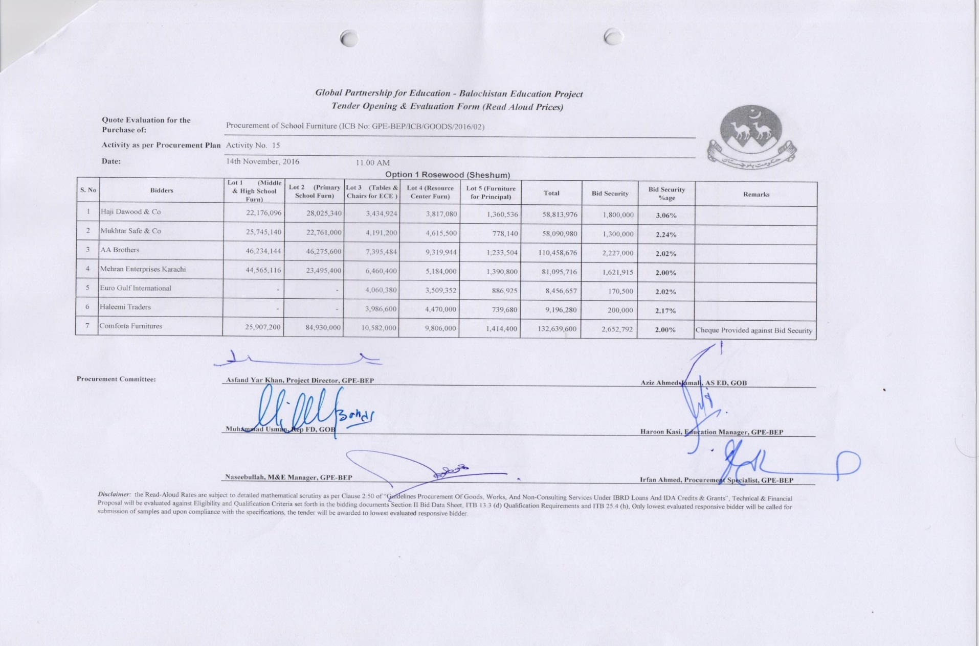

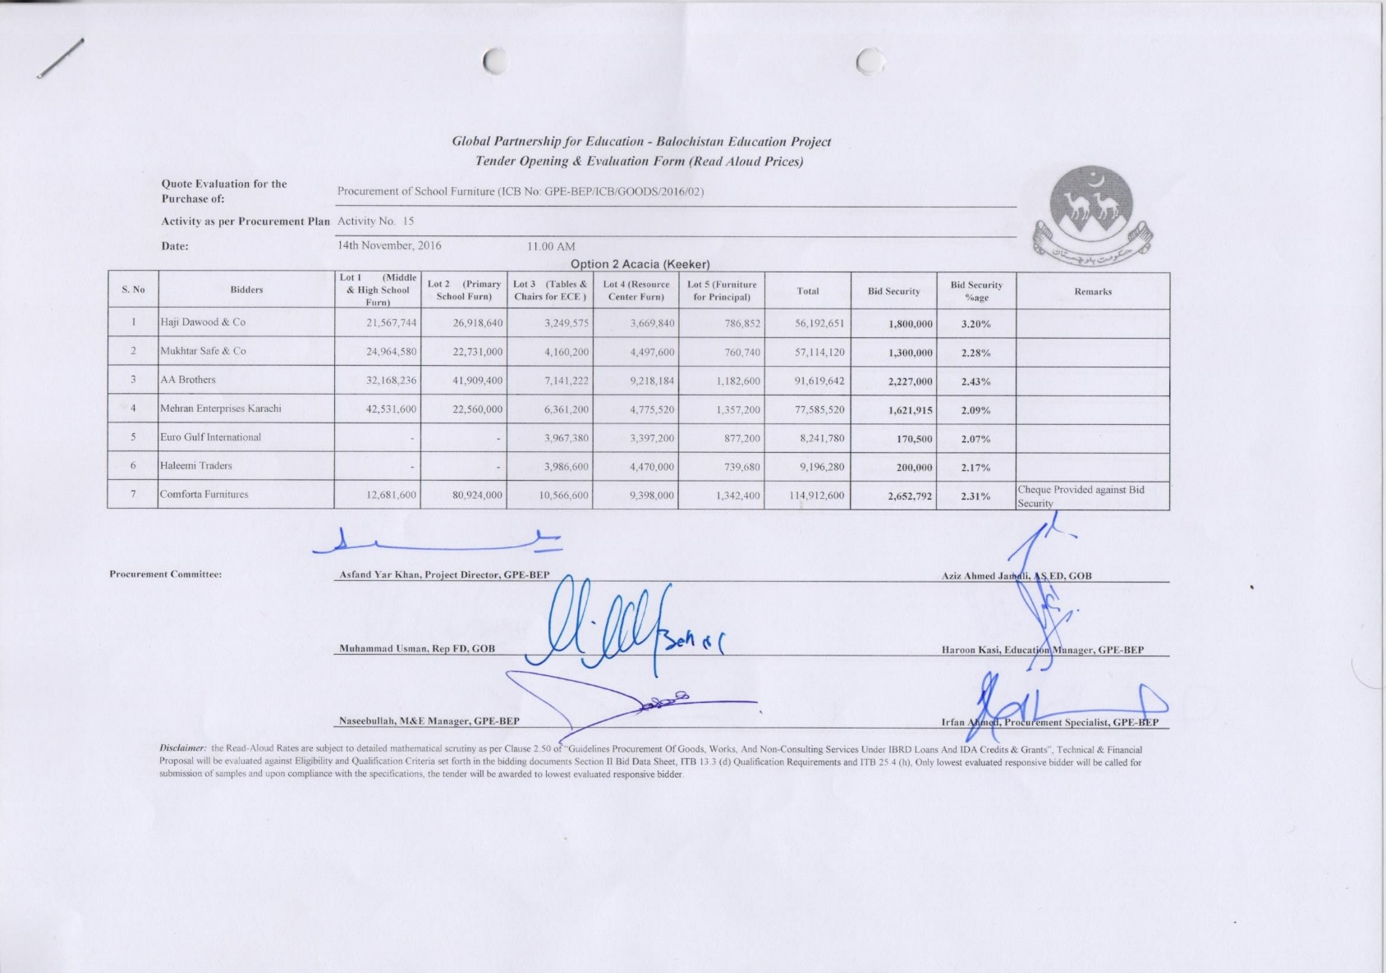

# Annex C

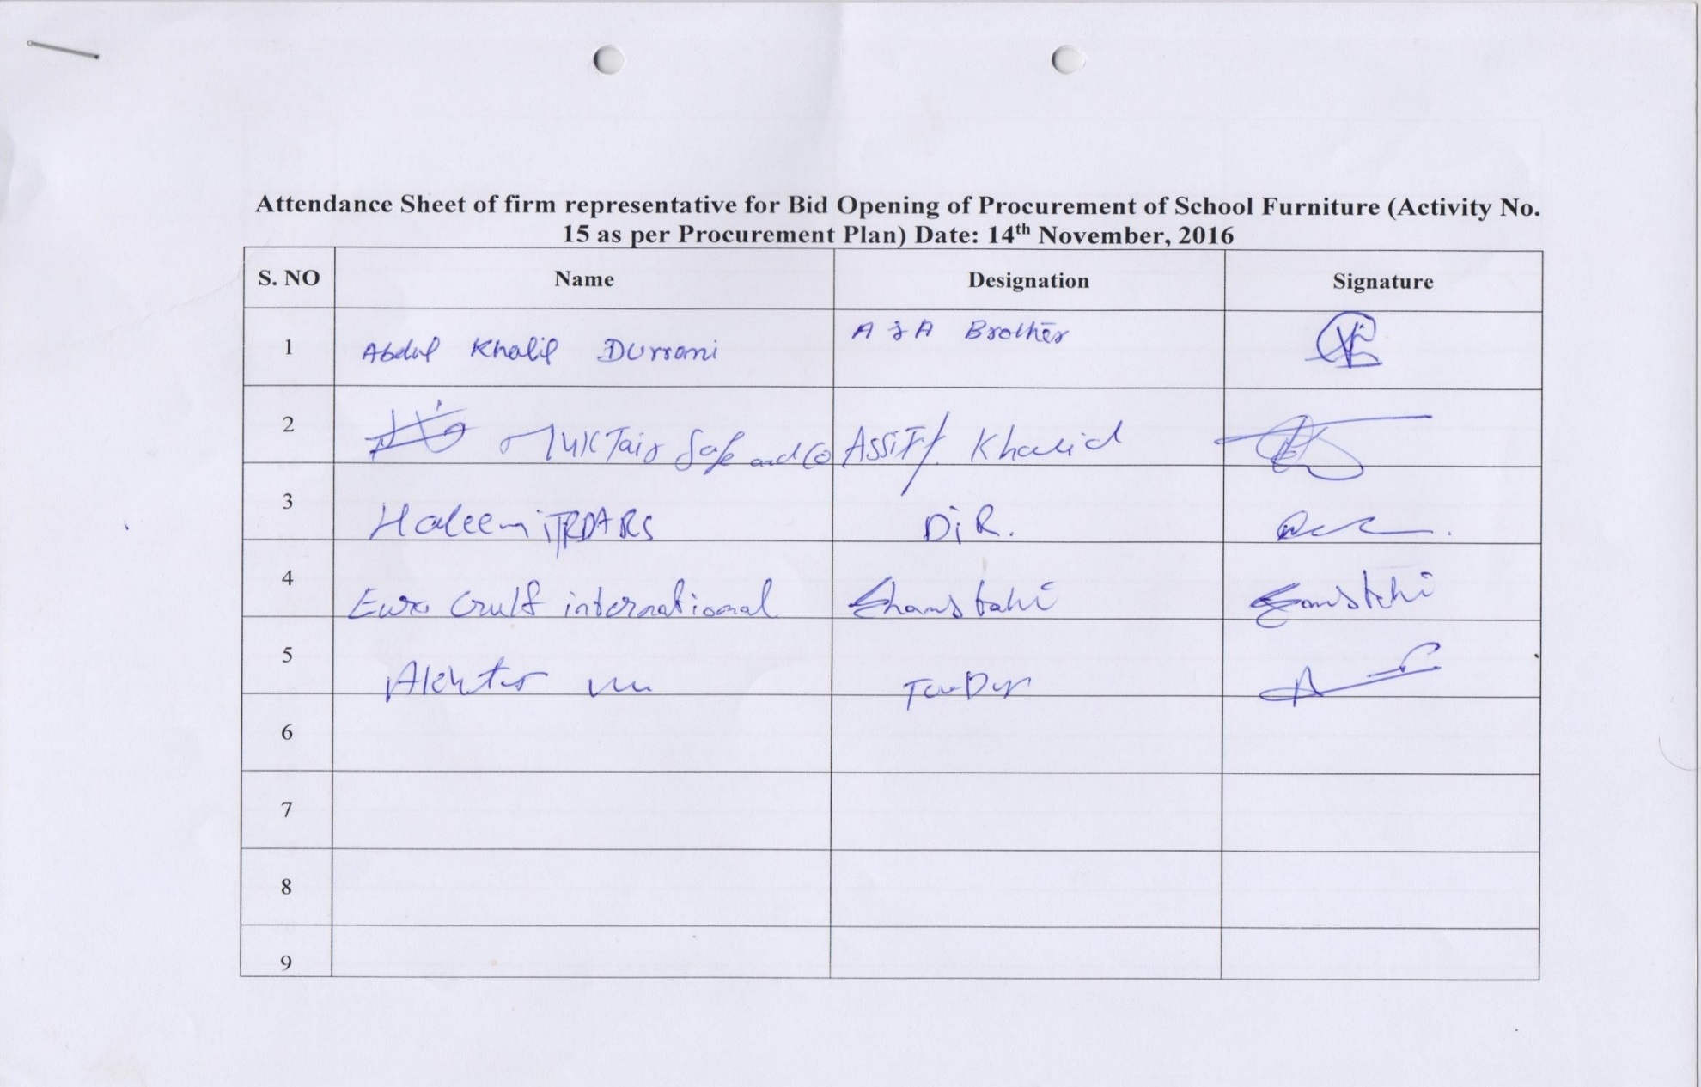

# Annex D

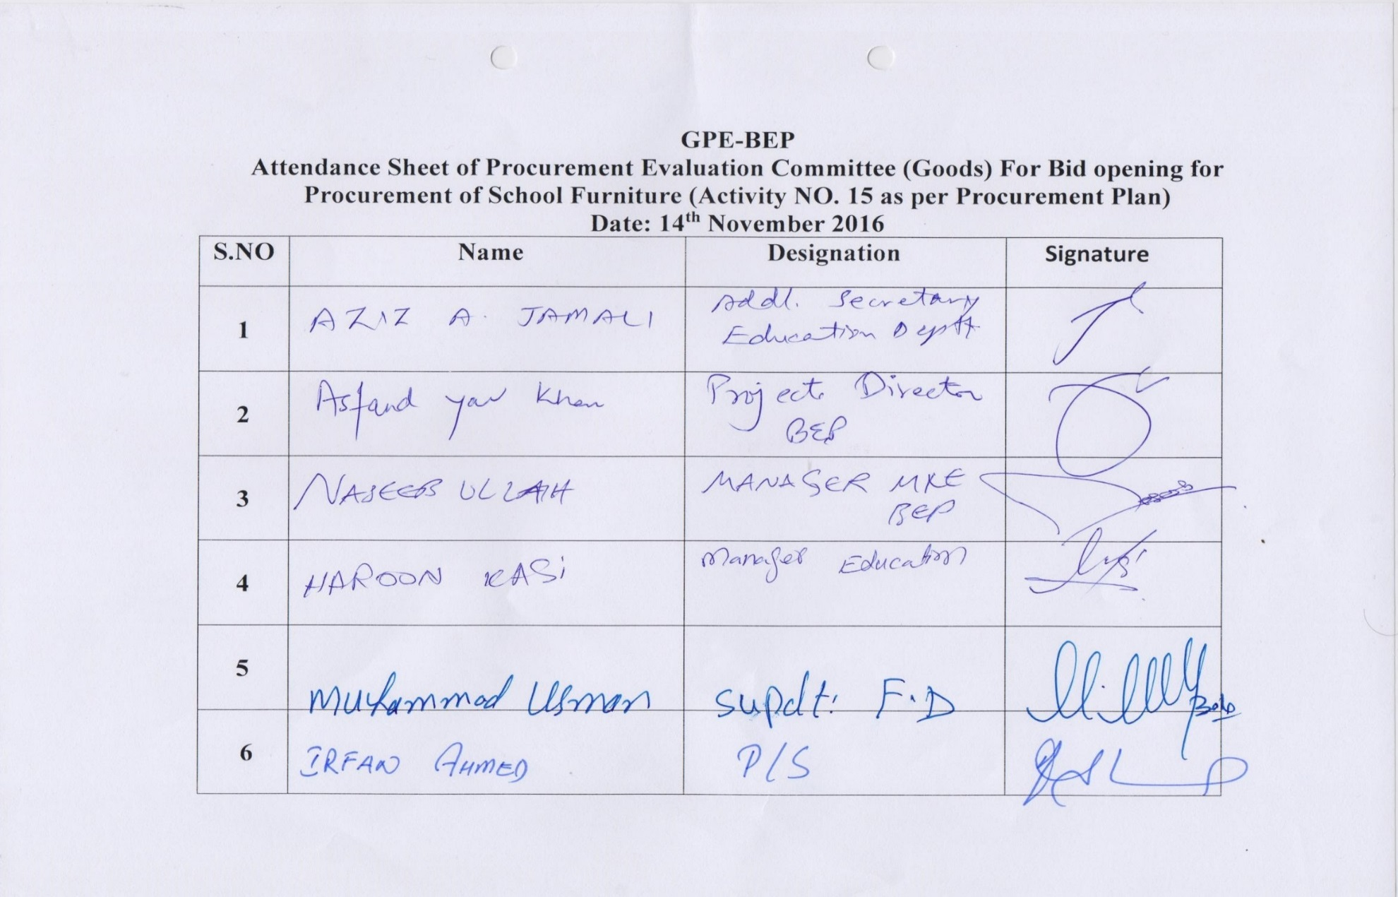

# Annex E

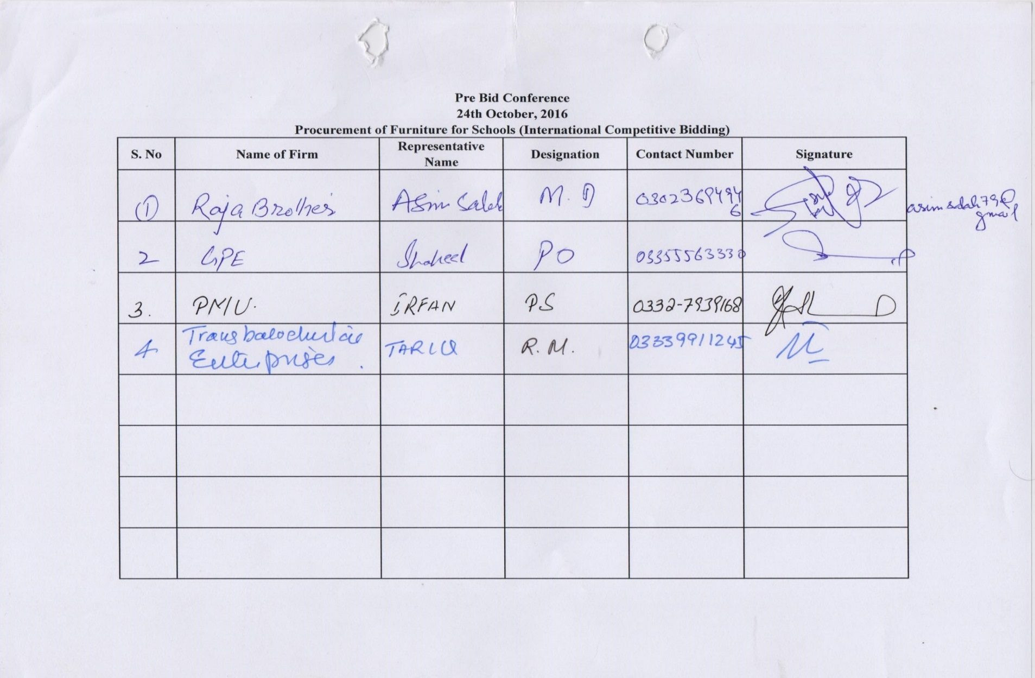

# Annex F

